**ACCRA TECHNICAL UNIVERSITY**

**DESIGNING AND IMPLEMENTATION OF A MOBILE APPLICATION SYSTEM FOR SECURITY GUARD ALLOCATION SYSTEM: (A CASE STUDY IN ACCRA)**

**By**

**DZREKE-POKU NATHAN KODZO**

**(01200972D)**

**LARTEY EMMANUEL KOJO**

**(01203163D)**

**NYAABILA MATTHEW**

**(01201862D)**

**RESEARCH PROJECT REPORT/ THESIS Submitted to the**

**DEPARTMENT OF COMPUTER SCIENCE,**

**FACULTY OF APPLIED SCIENCES,**

**in Partial Fulfilment of the Requirements for the**

**AWARD OF A HIGHER NATIONAL DIPLOMA (HND)**

**In**

**COMPUTER SCIENCE**

**SEPTEMBER, 2023**

# DECLARATION BY STUDENTS

This project is submitted as part of fulfilment for the award of a **HND** in **Computer Science**: The work is a result of our investigation. All section of the text and results which have been obtained from other works/ sources are fully referenced. We understand that cheating and plagiarism constitute a breach of Accra Technical University and will be dealt with accordingly.

**NAME SIGNATURE DATE**

**DZREKE-POKU NATHAN KODZO ……………… ………………**

**(01200972D)**

**LARTEY EMMANUEL KOJO ……………… ………………**

**(01203163D)**

**NYAABILA MATTHEW ……………… ………………**

**(01201862D)**

# DECLARATION BY SUPERVISOR

I hereby confirm that the above students are **HND Students** in the **Department of Computer Science** under my academic and research supervision in accordance with the project work requirements in Accra Technical University.

**NAME SIGNATURE DATE**

**PROF. NANA YAW ASABERE ……………… ………………**

# DEDICATION

We dedicate this book to the Most High God, our lovely parents, our siblings, our friends and all our lecturers for their support assistance throughout our training.

# ACKNOWLEDGEMENTS

We will take this opportunity to show our gratitude to everyone who made this project a success. However, it will not have been possible without the kind support and help of our classroom colleagues. We would like to extend our sincere thanks to all of them. We are highly indebted to our Supervisor, HOD etc. for their guidance and constant supervision providing necessary information regarding the project and also their support in completion. We will like to express our gratitude towards our mom for her kind cooperation and encouragement which helped in the completion of this project.

# ABSTRACT

Teaching is an interactive process that involves instructor and student interaction throughout particular tasks in the classroom. It disseminates information to increase comprehension. Learning, on the other hand, entails understanding abstract concepts, recalling details, picking up techniques, and obtaining problem-solving abilities that can be applied in various contexts. Our research investigates the current method of teaching and learning Computer Science theoretical courses in Computer Science Department of Accra Technical University (ATU). We identified that in relation to some selected theoretical courses, students in Computer Science Department of ATU, encounter some difficulties in the traditional way of teaching and learning which is delivered via face-to-face lectures and zoom online lectures.

To achieve this goal, we adopted a mixed-method strategy that combined qualitative, quantitative and build computer science research methods. Our study's findings indicate that the majority of students and lecturers are keen to adopt gamification. For the purpose of engaging students in this study, this research tackled the previously mentioned problem by proposed and developing a mobile game software with game components to support students in an instructive and compelling style of learning in ATU’s Computer Science Department.

Furthermore, our developed gamification solution improves learning of computer science theoretical courses. Our proposed gamification solution, aids computer science students in ATU to gain more motivation and persistence, increasing their engagement as well as improving peer collaborative learning, compared to the current method of teaching and learning computer science theoretical courses.

# TABLE OF CONTENTS

**CONTENTS PAGES**

**DECLARATION BY STUDENTS i**

**DECLARATION BY SUPERVISOR i**

**DEDICATION ii**

**ACKNOWLEDGEMENTS iii**

**ABSTRACT iv**

**TABLE OF CONTENTS v**

**LIST OF FIGURES viii**

**LIST OF TABLES ix**

**CHAPTER ONE 10**

**INTRODUCTION 10**

1.1 BACKGROUND OF THE STUDY 10

1.2 STATEMENT OF THE PROBLEM 12

1.2.1 Research Questions 12

1.3 OBJECTIVES OF THE STUDY 12

1.4 SIGNIFICANCE OF THE STUDY 13

1.5 ORGANIZATION OF THE STUDY 14

**CHAPTER TWO 15**

**LITERATURE REVIEW 15**

2.0 INTRODUCTION 15

2.1 DEFINITION OF GAMIFICATION IN EDUCATION 15

2.2 THEORETICAL BACKGROUND OF GAMIFICATION 15

2.3 BENEFITS OF GAMIFICATION 16

2.4 RESEARCH STUDIES ON THE EFFECTIVENESS OF GAMIFICATION IN TEACHING AND LEARNING COMPUTER SCIENCE 16

2.5 RELATED WORK IN THE USE OF GAMIFICATION FOR EDUCATION 17

**CHAPTER THREE 19**

**RESEARCH METHODOLOGY 19**

3.0 INTRODUCTION 19

3.1 DATA COLLECTION INSTRUMENTS 19

3.2 POLUATION AND STUDY AREA 19

3.3 SAMPLE SIZE 20

3.4 RESULTS AND ANALYSIS 20

3.4.1 Demography and Profile of the Respondent 20

3.4.2 Qualitative Results and Analysis 27

3.5 RESEARCH DISCUSSION 29

**CHAPTER FOUR 31**

**PROPSED SYSTEM IMPLEMENTATION 31**

4.0 INTRODUCTION 31

4.1 SYSTEM DEVELOPMENT / IMPLEMENATION TOOLS 31

4.1.0 Android Studio 31

4.1.1 Java Programming Language 31

4.1.2 Firebase 31

4.1.3 XML Layouts 32

4.1.4 Glide (Image Loading Library) 32

4.1.5 Recycler View 33

4.1.6 Version Control (Git and GitHub) 33

4.1.7 Device for Physical Testing 33

4.2 DATABASE IMPLEMTATION 33

4.2.1 Authentication (Firebase Authentication) 33

4.2.2 Real-Time Database 34

4.2.3 Storage (Firebase Cloud Storage) 34

4.2.4 Cloud Functions (Firebase Cloud Functions) 36

4.2.5 Push Notifications (Firebase Cloud Messaging) 36

4.3 SYSTEM REQUIREMENTS 36

4.3.1 User Requirements 37

4.3.2 Functional Requirements 37

4.3.3 Non – Functional Requirements 39

4.3.4 Requirement for System Implementation and Operations 39

4.4 SYSTEM OVERVIEW 40

4.4.1 User Requirement and Analysis 40

4.5 THE PROPOSED SYSTEM’S USER INTERFACES AND EXPERIENCES 40

4.5.1 Splash Screen 41

4.5.2 Create Account Form 42

4.5.3 Login Page 43

4.5.4 Create Profile 44

4.5.5 Profile Page 45

4.5.6 Leaderboard 46

4.5.7 Achievements 46

4.5.8 Challenge 47

4.5.9 Results 48

4.5.10 Community 49

**CHAPTER FIVE 51**

**SUMMARY, CONCULSIONS AND RECOMMENDATIONS 51**

5.0 CONCLUDING REMARKS 51

5.1 RECOMMENDATIONS 51

**REFERENCES** 52

**appendix** 55

**SURVEY QUESTIONNAIRE FOR STUDENTS** 55

6.0 INTRODUCTION 55

# LIST OF FIGURES

Figure 3. 1: Qualitative Analysis Process 27

Figure 3. 2: Device Mostly Used 29

Figure 4. 1: Firebase Project Overview 32

Figure 4. 2: Firebase Authentication 34

Figure 4. 3: Firebase Cloud Storage 35

Figure 4. 4: Use Case Diagram 37

Figure 4. 5: Splash Screen 41

Figure 4. 6: Create Account 42

Figure 4. 7: Login Page 43

Figure 4. 8: Create Profile 44

Figure 4. 9: Profile 45

Figure 4. 10: Leaderboard 46

Figure 4. 11: Achievement Page 47

Figure 4. 12: Challenge Page 48

# LIST OF TABLES

Table 3. 1: Profile of Respondents 21

Table 3. 2: Survey Response to Access the Current Method of Teaching and Learning CPS Theoretical Courses in the ATU Department 22

Table 3. 3: Survey Response of the Newly Proposed System 24

Table 4. 4: Interview Response of Lecturers in ATU Computer Science Department 28

# CHAPTER ONE

# INTRODUCTION

## 1.1 **BACKGROUND** OF THE STUDY

A security agency is a national organization that is a part of the government and is responsible for intelligence operations. They are the domestic cousins of international intelligence services, and their usual function is to oppose the foreign intelligence operations of other nations (Bamford, 2002). A security guard is a person employed by a government or private party to enforce preventative measures to safeguard the employing party's assets (property, people, equipment, money, etc.) against a variety of hazards (such as crime, waste, damages, unsafe worker behavior, etc.). Security guards are also known as security inspectors, security officers, factory guards, or protective agents (Davis, 1956). The general definition of information security comprises availability, integrity, and confidentiality (Safa et al, 2016).

Given that data breaches, identity theft, and other internet frauds may be fatal to organizations, security management is of utmost importance (Soomro et al, 2016).

In relation to academic importance, computer science theoretical courses are crucial for students pursuing careers in the tech industry. These courses provide the foundational knowledge and skills required to develop and analyze algorithms, design efficient data structures, and develop computer programs. However, the abstract nature of these courses can make it difficult for students to understand the practical applications of the concepts they are learning. Gamification can provide a way to bridge the gap between theory and practice by allowing students to engage with the material in a fun and interactive way. This can improve their understanding of the concepts and help them to see the practical applications of what they are learning (Riding & Rayner, 2013). From a practical view, gamification has been shown to improve engagement and motivation in various educational settings (Smiderle et al., 2020). By incorporating game elements into the learning process, students are more likely to remain focused and interested in the material (Rabah et al., 2018). Additionally, gamification can provide immediate feedback and rewards for progress, which can be a powerful motivator for students. This can lead to improved academic performance and retention of knowledge.

Several studies have explored the potential of gamification to enhance the teaching and learning of computer science courses. For instance, according to Dichev & Dicheva (2017), gamification is a social construct that encourages individuals involved to participate in a particular way. A study conducted by Kamasheva et al. (2019) reveals that gamification is a method of encouraging the enjoyment of accomplishment. In another study, Gil-Acirón (2022) discovered that, games entail the existence of a parallel universe where rewards, fun and competition inspire people to act. These findings suggest that gamification could be a promising approach to enhance the teaching and learning of theoretical computer science courses. The literature suggests that gamification can be an effective tool to enhance the teaching and learning of computer science theoretical courses. By leveraging gamification techniques, educators in the tertiary institutions can improve student engagement, motivation, and performance in theoretical computer science courses.

The current study aims to address these gaps and controversies by exploring the effectiveness of gamification in enhancing the teaching and learning of computer science theoretical courses in the Computer Science Department of Accra Technical University. Specifically, the study will investigate the effectiveness of a gamified approach to teach data structures and algorithms, fundamentals of computer programming, operating systems, information system analysis and design, database concepts and technologies, computer and information security, and software engineering with a focus on improving student engagement, motivation, and performance. The main contribution of this study is to provide empirical evidence on the effectiveness of gamification in enhancing the teaching and learning of computer science theoretical courses. By investigating the effectiveness of a gamified approach to teaching algorithms and data structures, the study will provide insights into the specific gamification techniques that are most effective in enhancing student engagement, motivation, and performance. The study’s contribution to the reader lies in the practical implications of the findings, which can be used to inform teaching practices in the Computer Science Department of Accra Technical University and other similar institutions. The findings can also inform the development of new gamification techniques that can be applied to other theoretical computer science courses. By improving the teaching and learning of computer science theoretical courses, the study can contribute to the development of a skilled and competent workforce in the field of computer science.

The study is being conducted in the Computer Science Department of Accra Technical University, which is located in Accra, Ghana. Accra Technical University is a leading institution for technical education in Ghana, offering a range of undergraduate and graduate programs in engineering, applied sciences, and technology.

## 1.2 STATEMENT OF THE PROBLEM

Computer Science Theoretical Courses, such as algorithms and data structures, are an essential component of computer science education. However, these courses can be challenging for students due to the abstract nature of the subject matter. The Computer Science Department at Accra Technical University faces a similar challenge. The teaching and learning activities related to these courses can be improved by engaging students to achieve a better understanding of each respective course.

To address this problem, gamification has been suggested as a potential solution. Gamification involves the use of game design elements and mechanics in non-game contexts to improve engagement and motivation. However, the effectiveness of gamification in improving the teaching and learning of theoretical computer science courses has not been fully explored in the context of Accra Technical University.

The current problem is related to teaching and learning, and gamification is a potential computerized solution that can address this issue. By analyzing the existing system and evaluating the effectiveness of gamification, this study will provide insights into whether gamification can be an effective solution for improving the teaching and learning of theoretical computer science courses.

## 1.2.1 **Research** Questions

The Research Questions our study tends to answer are;

* What is the current system of security allocation in Accra, Ghana?
* What are the challenges encountered in allocating security guards in security companies in Accra, Ghana?
* Which appropriate computerized software solution is required to tackle the identified challenges above in order to improve the current system?

## 1.3 OBJECTIVES OF THE STUDY

The objectives of this research project are as follows:

* To investigate the current system of allocating security guards in Accra, Ghana.
* To analyze the challenges of allocating security guards in security companies in Accra, Ghana.
* To propose a computerized game solution to improve the challenges in allocating security guards to their appropriate posts in Accra, Ghana.

## 1.4 **SIGNIFICANCE** OF THE STUDY

The study's significance is in its ability to enhance the system for assigning security guards in accordance with the needs of the organizations and people who use them. By helping agencies and people in need of protection hire security personnel from their respective agencies without requiring the involvement of all three parties—the security company, the agency or person in need of security guard, and the security guard—this study will aid in the development of a more efficient system.

The study's significance goes beyond the simple assignment of security personnel, because of the advancements in technology, societies in today's advanced world frequently face numerous issues and accidents (Zamaian et al., 2012).  The results of this study will have implications for the construction of a thorough and computational system that will assist organizations in need of security guards in meeting their security requirements.

Additionally, this research will offer worker satisfaction and safety the approach enhances worker satisfaction and safety by guaranteeing that guards are assigned according to workload, abilities, and preferences. When a guard's work assignments suit their interests and abilities, they are more likely to be satisfied.

Lastly, the study will make it possible for businesses to reserve security guards according to particular requirements, dangers, or priorities. The technology assists in optimizing the deployment of guards by taking into account variables including the size of the area that needs to be defended, the degree of threat, and past event data. The technology will enable real-time visibility over the location and status of security personnel. This enables security administrators to keep an eye on guards, react quickly to occurrences, and make decisions that are well-informed by the state of security at the time.

## 1.5 **ORGANIZATION OF THE STUDY**

This project work is structured as follows:

**Chapter One** – Chapter One elaborates on the background of study, problem statement, research questions of the study and the organization of the study in relation to allocating security guards in Accra, Ghana.

**Chapter Two** – This chapter review the literature relating to designing a comprehensive mobile application for stakeholders in appointing security guards to their respective posts,

**Chapter Three** – Chapter Three summarizes deals with the methods utilized in the research project for obtaining the necessary data for effective analysis.

**Chapter Four** – Chapter Four presents our proposed security allocation system in terms of the software development and implementation procedure.

**Chapter Five** – This chapter summarizes and concludes the study and provides some recommendations.

# CHAPTER TWO

# LITERATURE REVIEW

## **INTRODUCTION**

This section presents a summary of the literature and its components. The literature evaluation of the use of mobile application to improve allocation of security personnel. The literature evaluation of allocating security guards using a computerized system for security companies in Accra is focused on essential components such as (i) definition of security, (ii) benefits of security systems (iii) effectiveness of the implementation of security (iv) related work of allocating security guards.

## 2.1 **DEFINITION OF GAMIFICATION IN EDUCATION**

Gamification is a concept that was coined early in the twenty-first century, and its ideas have been applied in the corporate sector Kamasheva et al. (2019). Gamification which is defined as the use of game mechanics, dynamics, and frameworks to encourage desirable behaviors, has made its way into fields such as education, marketing, politics, health, and fitness, with experts projecting that it will become a multibillion-dollar business (Lee & Hammer, 2011). It is the use of game design elements in non-game contexts (Deterding et al., 2011; Dichev & Dicheva, 2017; Nair & Mathew, 2019).

## 2.2 THEORETICAL BACKGROUND OF GAMIFICATION

Gamification is a multidisciplinary notion that spans theoretical and empirical knowledge, technical disciplines, and platforms, and is motivated by a variety of practical motives (Dichev & Dicheva, 2017). According to the Gamified Learning Theory, gamification does not directly affect learning but rather activates a learning-related behavior via a mediating or moderating process. Learner-related behavior may be anticipated to some extent depending on how learners perceive, comprehend, and apply knowledge. These various modes of learning are referred to as learning inclinations (Zaric et al., 2021). It will never be evident why these tactics impact results as they do without a theoretical model combining the precise approaches adopted by instructional designers to gamify learning with the consequences of their efforts (Landers, 2015).

## 2.3 BENEFITS OF GAMIFICATION

Researchers developed an online social network site in which badging was used to push students to complete optional online multiple-choice assessments in order to improve their learning (Landers, 2015). To some extent, learner-related behavior may be anticipated based on how learners perceive, comprehend, and apply knowledge (Zaric et al., 2021). Games are especially well-known for their capacity to interest and excite people, and when they play games, they typically experience mastery, competence, enjoyment, immersion, or flow, all of which are characteristics of intrinsically driven human behavior (Koivisto & Hamari, 2019). They can provide a rich learning setting in which learners can create higher-level information through confusing and difficult trial-and-error possibilities (Mee et al., 2020). According to the findings, gamification has the ability to make the learning process more inspiring and engaging for pupils (Zahedi et al., 2019). The following benefits were obtained from literature on the benefit of gamification in education:

1. A study conducted by Poondej & Lerdpornkulrat (2016) reveals that, gamification can make learning more fun and interactive, which can lead to increased engagement and motivation among students.
2. Gamification fosters personalized learning experiences, where students can work at their own pace and receive immediate feedback (An, 2020).
3. By making learning more interactive and engaging, students are more likely to retain the information they learn (Smiderle et al., 2020).
4. Gamification often requires students to solve problems, which can help develop critical thinking and problem-solving skills (Bourke, 2019; Mposula, 2019).
5. By promoting collaboration, problem-solving, and engagement, gamification can help create a positive classroom culture where students are excited about learning (Adipat et al., 2021).

## 2.4 RESEARCH STUDIES ON THE EFFECTIVENESS OF GAMIFICATION IN TEACHING AND LEARNING COMPUTER SCIENCE

In the context of computer science as an academic programme, several studies have been conducted to show the importance and effectiveness of gamification. Özdamli & Yazdeen (2021) emphasized that further studies are required to discover whether this has an influence on final performance and governs specific groups affects. Previous studies have demonstrated that gamification has a good influence on motivating learning, boosting learning performance, and improving overall competence (Zhan et al., 2022). According to the mixed-methods study by Zahedi et al., (2019), gamified learning activities increased students' engagement and enhanced their academic achievement. Some tested systems such as Feeper is a web-based solution that helps computer science students and professors in programming lessons. The teacher may present programming exercises in the environment, which students can solve and have automatically rectified by an Online Judge linked into the platform (Smiderle et al., 2020). Because computer science provides the foundation of such games, there is a special link between digital games and computer science. Furthermore, the programming process incorporates many of the same aspects present in games (Johnson et al., 2016).

**2.5 RELATED WORK IN THE USE OF GAMIFICATION FOR EDUCATION**

In this section, we evaluate existing gamification research in education in relation to computer science categorization in the literature in this part to support the notion of a computerized gaming system for computer science theoretical courses at Accra Technical University in Ghana.

Zhan et al. (2022) investigated the influence of gamification on programming education by a meta-analysis of 21 empirical research published in the previous decade. Their study looks at how different types of games, gamification apps, pedagogical agents, programming types, and education levels affect students' academic success, cognitive load, motivation, and thinking abilities. According to the findings of their meta-analysis, gamification has a good influence on programming education, with the highest effect being on students' motivation, followed by academic accomplishment, and the least effect being on cognitive load.

Li et al. (2013) explored the use of gamification to engage Computer Science students in PeerSpace, an online social network-based collaborative learning environment, by describing the design and implementation details of several gamification schemes employed. The success of gamification schemes is evaluated, with emphasis on the influence of gamification on student engagement and involvement, as well as the consequences of various gamification mechanisms. The findings of Li et al. (2013) indicate that gamification may be an effective method for engaging Computer Science students in online collaborative learning settings, emphasizing gamification's ability to boost student engagement and involvement.

The potential of games as a tool for improving computer science education by boosting student motivation, active learning, adaptivity, cooperation, and simulation is discussed in a research by (Johnson et al., 2016). They studied a document from the Game Development for Computer Science Education working group, which was formed to investigate the current role of games in computer science education, including where and how they fit into CS education. Their report includes a summary of existing digital games designed to enrich computing education, an index of where these games may fit into a teaching paradigm using the ACM/IEEE Computer Science Curricula 2013, and a guide to developing digital games designed to teach computer science knowledge, skills, and attitudes. Johnson et al. (2016) further emphasized games' potential as a helpful tool for computer science education and offers advice to educators interested in incorporating games into their teaching practice.

A recent study by Özdamli & Yazdeen (2021) examined how gamification might be used to boost interest and involvement among learners in computer science education, notably during the COVID-19 epidemic. Özdamli & Yazdeen (2021) examined past research on gamification and its effects on computer science students in higher education. Their findings suggest that gamification increases learners' attention, engagement, and knowledge of difficult topics while also providing them with optional challenges.

The above studies demonstrate how gamification has been used in the field of education to teach and learn computer science. However, game concepts are currently underutilized in the context of teaching and studying computer science at Accra Technical University. As a result, we want to address this need by using students and teachers at Accra Technical University as our target data.

# CHAPTER THREE

# RESEARCH METHODOLOGY

## 3.0 **INTRODUCTION**

This section introduces the research methodology and data collection strategy employed in our research. The chapter comprises of i) data collection instruments ii) population and study area iii) sample size and iv) results and analysis.

## 3.1 DATA COLLECTION INSTRUMENTS

This study utilized a mixed research method comprising Qualitative, Quantitative and Build Computer Science methodologies. The quantitative and qualitative will be used to collect data from the research participants and the build Computer Science method will be used to develop our proposed system. The study involves both lectures and students in the Computer Science Department at Accra Technical University. Based on the population of the lectures, the Qualitative method was used to obtain relevant data from lectures on how gamification will affect their method of teaching.

We used a quantitative method which involves survey questionnaires through an online Google Form for a selected sample size to determine how gamification will affect their method of learning. This data will then be analyzed to determine the best tools, strategies and techniques to employ in developing a comprehensive gaming system for the Computer Science department.

## 3.2 POLUATION AND STUDY AREA

Students and lecturers of Accra Technical University Computer Science Department were the subjects involved in our study. The computer science department has three High National Diploma (HND) levels, namely: levels 100, 200 and 300. Each level is also sub-divided into morning or full-time and evening also known as part-time. The morning category is also further divided into three classes for all level labelled as CPS A, CPS B and CPS C. The research involves participants from all levels. As a result, a total target population 1,203 students were established. An online survey was sent to students of each class.

## 3.3 SAMPLE SIZE

To ensure the validity and reliability of our sample size of respondents, we employed a widely used mathematical equation from Kothari (2004), as shown in the following equation.

$n= \frac{Z^{2}×p×q×N}{e^{2}×\left(N-1\right)+Z^{2}×p×q}$ (1)

Where n is size of sample, *N* is the size of population, *Z* is the standard variate at a given confidence level, *e* is the acceptable error (the precision) and *p* is the probability success, *q* = 1 – *p*. As a result, we employed (1) to obtain our estimated sample size (*n*). In order to calculate *n*, we used the following values in (1): *Z* = 1.96, *p* = 5% (0.05), *q* = 1 – 0.05 = 0.95, *N* = 1203, and *e* = 0.02. Equation (2) illustrates this calculation:

$n= \frac{{1.96}^{2}×0.05×0.95×1203}{{0.02}^{2}×\left(1203-1\right)+{1.96}^{2}×0.05×0.95}$ (2)

$$n= \frac{219.52}{0.6633}=330.95$$

As calculated in the above equation, our computed sample size was 330.95 (*n* = 330.95). For the analysis to be effective, we had to receive responses close to 330.95 or more. Regarding the sample size, we received 318 responses for effective data analysis as shown in the tabulated results below. Results of our data analysis are presented below in descriptive statistics and percentages.

## 3.4 RESULTS AND ANALYSIS

The section below presents the results of the study using descriptive inferences and statistics. Microsoft excel was used to analyze the data. Analytical data in descriptive statistics of our responses are tabulated below.

### 3.4.1 Demography and Profile of the Respondent

The results of our data in Table 3.1 reveals that, out of 318 respondents who participated, 86.8% are male and 13.2% are female, their age ranges are 15 – 20 years by 90 participants followed by 224 (70.4%) participants ranging from 21 – 30 years and 4(1.3) participants age between 31 – 40 years. We also found out that, out of the three levels in the ATU Computer Science Department, 28% constitute level 100, 34% level 200 and finally 38% of level 300, 89% of which were full-time and 11% part-time.

Table 3.1: Profile of Respondents

|  |  |  |  |
| --- | --- | --- | --- |
| **User Demographics** | | | |
| **Questions** | **Responses (CPS Students in ATU)** | | |
| Age Range | **Category** | **N** | **%** |
| 15 - 20 Years | 90 | 28.3 |
| 21 - 30 Years | 224 | 70.4 |
| 31 – 40 Years | 4 | 1.3 |
| 41 Years Above | 0 | 0 |
|  | **Total** | **318** | **100** |
| Gender | **Category** |  |  |
| Male | 276 | 86.8 |
| Female | 42 | 13.2 |
|  | **Total** | **318** | **100** |
| Current Level | **Category** |  |  |
| Level 100 | 89 | 28 |
| Level 200 | 108 | 34 |
| Level 300 | 121 | 38 |
|  | **Total** | **318** | **100** |
| Level Status | **Category** |  |  |
| Part-time | 35 | 11 |
| Full-time | 283 | 89 |
|  | **Total** | **318** | **100** |

Table 3.2 were made of questionnaires to access the current method of teaching and learning Computer Science Theoretical courses in the Computer Science department. Following the questions are the responds given by our participants. 87.4% responded that, the current method of teaching is the normal traditional way of teaching and 12.6% selected advanced and technological as the method of teaching in the CPS department. 15.7% choses the concepts are easy to understand and 84.3% selected difficult in understanding concepts.

Table 3.2: Survey Response to Access the Current Method of Teaching and Learning CPS Theoretical Courses in the ATU Department

|  |  |  |  |
| --- | --- | --- | --- |
| **Accessing The Current Method of Teaching and Learning Computer Science Theoretical Courses in CPS Department** | | | |
| **Questions** | **Responses (CPS Students in ATU)** | | |
| What teaching methods are currently used in Computer Science theoretical courses at Accra Technical University? | **Category** | N | % |
| Traditional teaching methods Advance and | 278 | 87.4 |
| Technological Teaching Methods | 40 | 12.6 |
| **Total** | **318** | **100** |
| What challenges do you face as a student in understanding Computer Science theoretical concepts? | **Category** |  |  |
| Easy understanding of concepts | 50 | 15.7 |
| Difficult understanding concepts | 268 | 84.3 |
| **Total** | **318** | **100** |
| The current mode of teaching and learning Computer Science theoretical courses is easy to understand. | **Category** |  |  |
| Strongly Disagree | 47 | 14.8 |
| Disagree | 154 | 48.8 |
| Neither Agree or Disagree | 64 | 20.1 |
| Agree | 39 | 12.3 |
| Strongly Agree | 14 | 4.4 |
| **Total** | **318** | **100** |
| The current way of teaching provides me with industry standards and practices. | **Category** |  |  |
| Strongly Disagree | 61 | 19.2 |
| Disagree | 141 | 44.3 |
| Neither Agree or Disagree | 61 | 19.2 |
| Agree | 44 | 13.8 |
| Strongly Agree | 11 | 3.5 |
| **Total** | **318** | **100** |
| I find myself motivated and engaged during classes for CPS theoretical courses. | **Category** |  |  |
| Strongly Disagree | 62 | 19.5 |
| Disagree | 116 | 36.5 |
| Neither Agree or Disagree | 72 | 22.6 |
| Agree | 53 | 16.7 |
| Strongly Agree | 15 | 4.7 |
| **Total** | **318** | **100** |
| There are collaborative activities incorporated into teaching and learning in the Computer Science Department. | **Category** |  |  |
| Strongly Disagree | 53 | 16.7 |
| Disagree | 116 | 36.5 |
| Neither Agree or Disagree | 73 | 23 |
| Agree | 60 | 18.9 |
| Strongly Agree | 16 | 5 |
| **Total** | **318** | **100** |
| Aside instructional hours, I have been able to interact with lecturers. | **Category** |  |  |
| Strongly Disagree | 58 | 18.2 |
| Disagree | 140 | 44 |
| Neither Agree or Disagree | 65 | 20.4 |
| Agree | 44 | 13.8 |
| Strongly Agree | 11 | 3.5 |
| **Total** | **318** | **100** |
| How would you rate the interaction and engagement between students and lectures during CPS theoretical courses period? | **Category** |  |  |
| 1 | 61 | 19.2 |
| 2 | 83 | 26.1 |
| 3 | 99 | 31.1 |
| 4 | 56 | 17.6 |
| 5 | 19 | 6 |
| **Total** | **318** | **100** |
| How would you rate the feedback and guidance provided by instructors in Computer Science theoretical courses? | **Category** |  |  |
| 1 | 60 | 18.9 |
| 2 | 88 | 27.7 |
| 3 | 106 | 33.3 |
| 4 | 46 | 14.5 |
| 5 | 18 | 5.7 |
| **Total** | **318** | **100** |
| How would you rate the assessment methods used to evaluate your understanding of Computer Science theoretical concepts? | **Category** |  |  |
| 1 | 61 | 19.2 |
| 2 | 91 | 28.6 |
| 3 | 97 | 30.5 |
| 4 | 52 | 16.4 |
| 5 | 17 | 5.3 |
| **Total** | **318** | **100** |

In relation to the responses from participants in Table 3.3, 36.5% agreed and 48.1% strongly agreed they would accept games as a method of teaching and learning Computer Science theoretical courses. 39.6% agreed and 43.7% strongly agreed they would find gamification useful as a tool of learning Computer Science theoretical courses. Participants also agreed using game tools would enable them enhance their knowledge in Computer Science theoretical courses (44% agreed, 40.3% strongly agreed). 41.8% agreed it is easy for them to access games anytime and anywhere and 42.5 percent also strongly agreed. Based on the survey question, gamification will increase my motivation in learning Computer Science theoretical courses, 43.4% strongly agreed, 41.8% agreed, 11.3% neither agreed nor disagreed, 2.8% disagreed and 1.3% strongly disagreed.

Furthermore, participant agreed that gamification will be a better improvement of the method of teaching and learning Computer Science theoretical courses. 45.3% strongly agreed, 38.7% agreed 11.6% neither agreed or disagreed while 2.8% disagreed and 1.6% strongly disagreed. We found out that 47.5% respondents strongly agreed that gamification will be an easy tool to learn. Following that, 41.8% agreed, 6.6% neither agree or disagree, 2.2% disagree and 1.9% strongly disagree. 42.1% strongly agree they have the necessary device to play games, and 40.6% also agreed. 46.5% of our participants strongly agree they prefer gamification to the current method of teaching and learning Computer Science theoretical courses.

Table 3.3: Survey Response of the Newly Proposed System

|  |  |  |  |
| --- | --- | --- | --- |
| **Survey Response of the Proposed System** | | | |
| What device do you use mostly? | **Category** | N | % |
| Laptop | 41 | 12.9 |
| Smartphone | 227 | 87.1 |
| Total | **318** | **100** |
| I would accept games as a method of teaching and learning Computer Science theoretical courses. | **Category** |  |  |
| Strongly Disagree | 5 | 1.5 |
| Disagree | 15 | 4.7 |
| Neither Agree or Disagree | 29 | 9.1 |
| Agree | 116 | 36.5 |
| Strongly Agree | 153 | 48.1 |
| Total | **318** | **100** |
| I would find gamification useful as a tool of learning Computer Science theoretical courses. | **Category** |  |  |
| Strongly Disagree | 7 | 2.2 |
| Disagree | 14 | 4.4 |
| Neither Agree or Disagree | 32 | 10.1 |
| Agree | 126 | 39.6 |
| Strongly Agree | 139 | 43.7 |
| Total | **318** | **100** |
| Using game tools would enable me to enhance my knowledge in Computer Science theoretical courses. | **Category** |  |  |
| Strongly Disagree | 4 | 1.3 |
| Disagree | 11 | 3.5 |
| Neither Agree or Disagree | 35 | 11 |
| Agree | 140 | 44 |
| Strongly Agree | 128 | 40.3 |
| Total | **318** | **100** |
| It is easy for me to access games anytime anywhere. | **Category** |  |  |
| Strongly Disagree | 5 | 1.6 |
| Disagree | 11 | 3.5 |
| Neither Agree or Disagree | 34 | 10.7 |
| Agree | 133 | 41.8 |
| Strongly Agree | 135 | 42.5 |
| Total | **318** | **100** |
| Gamification will increase my motivation in learning Computer Science theoretical courses. | **Category** |  |  |
| Strongly Disagree | 4 | 1.3 |
| Disagree | 9 | 2.8 |
| Neither Agree or Disagree | 36 | 11.3 |
| Agree | 131 | 41.2 |
| Strongly Agree | 138 | 43.4 |
| Total | **318** | **100** |
| My interaction with game tools will enable me develop more interest in learning Computer Science theoretical courses. | **Category** |  |  |
| Strongly Disagree | 4 | 1.3 |
| Disagree | 8 | 2.5 |
| Neither Agree or Disagree | 36 | 11.3 |
| Agree | 137 | 43.1 |
| Strongly Agree | 113 | 41.8 |
| Total | **318** | **100** |
| Gamification will be a better improvement of the method of teaching and learning Computer Science theoretical courses. | **Category** |  |  |
| Strongly Disagree | 5 | 1.6 |
| Disagree | 9 | 2.8 |
| Neither Agree or Disagree | 37 | 11.6 |
| Agree | 123 | 38.7 |
| Strongly Agree | 144 | 45.3 |
| Total | **318** | **100** |
| Games will be easy to use when learning. | **Category** |  |  |
| Strongly Disagree | 6 | 1.9 |
| Disagree | 7 | 2.2 |
| Neither Agree or Disagree | 21 | 6.6 |
| Agree | 133 | 41.8 |
| Strongly Agree | 151 | 47.5 |
| Total | **318** | **100** |
| I use other related game sites and services to learn Computer Science theoretical courses. | **Category** |  |  |
| Strongly Disagree | 7 | 2.2 |
| Disagree | 37 | 11.6 |
| Neither Agree or Disagree | 43 | 13.5 |
| Agree | 105 | 33 |
| Strongly Agree | 136 | 39.6 |
| Total | **318** | **100** |
| I would recommend gamification to others offering Computer Science. | **Category** |  |  |
| Strongly Disagree | 6 | 1.9 |
| Disagree | 7 | 2.2 |
| Neither Agree or Disagree | 31 | 9.7 |
| Agree | 136 | 42.8 |
| Strongly Agree | 138 | 43.4 |
| Total | **318** | **100** |
| I have the necessary devices to play games. | **Category** |  |  |
| Strongly Disagree | 3 | 0.9 |
| Disagree | 21 | 6.6 |
| Neither Agree or Disagree | 31 | 9.7 |
| Agree | 129 | 40.6 |
| Strongly Agree | 134 | 42.1 |
| **Total** | **318** | **100** |
| I prefer gamification to the current method of teaching Computer Science theoretical courses. | **Category** |  |  |
| Strongly Disagree | 5 | 1.6 |
| Disagree | 15 | 4.7 |
| Neither Agree or Disagree | 33 | 10.4 |
| Agree | 117 | 36.8 |
| Strongly Agree | 148 | 46.5 |
| **Total** | **318** | **100** |

### 3.4.2 Qualitative Results and Analysis

We interviewed three Computer Science lecturers with the aim to substantiate our study. The interview was conducted solely in English. All interviews were audio recorded and transcribed by the interviewers. The transcripts were manually categorized into themes or categories, and were continuously compared to concentrate on the crucial themes and connections that emerged for a thorough comprehension of the participant's feedback and below is our results and analysis.

Open Coding

Document and feedback from each respondent were examined and responses were manually coded.

Descriptive Coding

For additional analysis and graphical representation of the data, each question and categories from the manual coding process were summarized for a clear overview

manual coding process where entered into google forms software

Quotation Coding

Specific quotes from the interview transcripts were further analyzed manually to illustrate and support our key findings and themes

Figure 3.1: Qualitative Analysis Process

Table 4.4: Interview Response of Lecturers in ATU Computer Science Department

|  |  |  |  |  |
| --- | --- | --- | --- | --- |
| **Interview Response of Lecturers** | | | | |
| S/N | What course do you teach? | How many students do you teach? | As a lecturer, how do you assess the effectiveness of Gamification in your Computer Science theoretical course? | Would you accept Gamification as a tool for teaching and learning computer science theoretical courses? |
| P1 | “*Information System Analysis and Design, Digital Signal Processing at B-Tech level, as well as Computer Literacy*” | “*Averagely Computer Literacy, 500 students, Information System Analysis, 400 students, DSP the highest so far is 79 students which is B-Tech level.”* | “*For courses that I teach, it involves a lot of practical and if I try to make use of your system, basically, it’s going to reduce some practical lessons especially, Data Signal Processing, it’s going to be of a good help for students and a lecturer as myself, it’s going to reduce some hours of teaching theoretically, and being able to veer off your system where actual implementation of theories into practical can be well explained by the students, so accessing it is something very good to the benefit of the students.”* | “*Yes, I will accept it*.” |
| P2 | *“Operating Systems”* | *“I teach about 500 students”* | *“**Gamification enhances level of engagement and accessibility of students in the classroom in a fun way”* | *“Yes”* |
| P3 | *“I teach Professional and Social Computing and then Data and Telecommunication Technologies”* | *“This is around 300 to 320, depending on the class.”* | *“Well game is good, actually game makes class or sessions lively so if game can be applied, then it’s good. Basically it’s normally used in the basic level or lower levels but then I don’t rule it out that it cannot be used here.”* | *“Game is suitable for some semi-practical courses so you can use it.”* |

From Table 3.4 above, we got responses from three lecturers teaching a total of six (6) courses. Participants 1 (P1) teaching a population of about 500 in Computer Literacy, 400 in Information System and Analysis and 79 Data Signal Processing at the B-Tech Level. Following the question, “As a lecturer, how do you access the effectiveness of Gamification in your Computer Science theoretical course?”, P1 gave a positive response that, gamification will reduce some practical sections and will be of a good help as students as well as lecturers. P2 also stated that, gamification enhances level of engagement and accessibility of students in the classroom in a fun way. According to responses from P3, who teaches Professional and Social Computing as well as Data Communication and Telecommunication accepted the notion that gamification will be a useful and fun way of teaching and learning of CPS theoretical courses. All Participants agreed they would accept gamification as a tool for teaching and learning Computer Science theoretical courses.

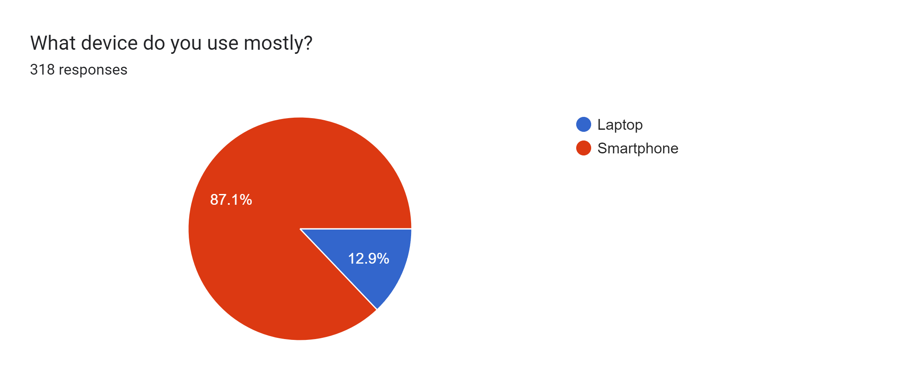

Figure 3.2: Device Mostly Used

## 3.5 RESEARCH DISCUSSION

With reference to Table 3.2, we identified that the current method used in teaching are the traditional method of teaching which is a lecturer student interaction. Also, responses from participants back our proposal that the department lack effective and innovative pedagogy in teaching and learning as a challenge faced by the current method of teaching and learning. In Table 3.3, we proposed our suggested solution to respondents about introducing gamification in addition to the already existing method of teaching and learning. Responses shows that over 70% agree on the use of gamification to improve teaching and learning.

Subsequently, a qualitative study approach was used to interview instructors from the ATU Computer Science department to determine how they evaluate the efficiency of gamification in the teaching and learning of computer science theoretical courses. Gamification is an excellent teaching and learning approach in computer science theoretical courses, according to the responses from these few instructors, provided it is implemented carefully and is in line with the learning objectives and content. They agreed that adding game aspects like points, badges, leaderboards, and competitions among students can make learning more enjoyable. Additionally, they acknowledge that when gamified activities feature competitive or achievement-based elements, students are more likely to engage actively.

Based on the tabulated analysis and findings shown above, we can conclude that the respondents are willing to adapt and accept our suggested mobile-based software for enhancing the teaching and learning processes in the computer science department at Accra Technical University. subsequently, in the following chapter, we go into greater detail about our suggested approach.

# CHAPTER FOUR

# PROPSED SYSTEM IMPLEMENTATION

## 4.0 INTRODUCTION

This chapter describes the setup of our proposed computerized gamification mobile app system. The chapter depicts system development and implementation tools, system requirements, database implementations, and system interfaces for the primary stakeholders (Students of ATU). The chapter further discusses how users can easily use the system, from launching the application, creating an account and logging in and understanding how to use this application in challenging among themselves and each other in learning CPS theoretical courses till logging out.

## 4.1 SYSTEM DEVELOPMENT / IMPLEMENATION TOOLS

This section documents all the essential tools used in developing and implementing our proposed system from start to a complete finish.

### 4.1.0 Android Studio

The official Integrated Development Environment (IDE) for creating Android apps is Android Studio. Android Studio, which is based on the robust code editor and developer tools from IntelliJ IDEA, offers additional features that increase work efficiency when creating Android apps, such as: i) a versatile build system based on Gradle, ii) a powerful and quick emulator iii) a single environment where work can be done on Android projects for all devices iv) live edit to instantly update composable on physical devices and emulators and v) extensive testing frameworks and tools.

### 4.1.1 Java Programming Language

Java is the major programming language used for creating Android applications. It is used to write our app's logic and functionality. In our project, we used Java with other frameworks to complete our proposed topic.

### 4.1.2 Firebase

Firebase is a platform by Google that offers various services for building and scaling apps. For our project, we used Firebase Authentication for user sign-in and sign-up, Firebase Firestore for storing user data and gamification-related information, Realtime Database for updating user data and Firebase Cloud Messaging for sending notifications.

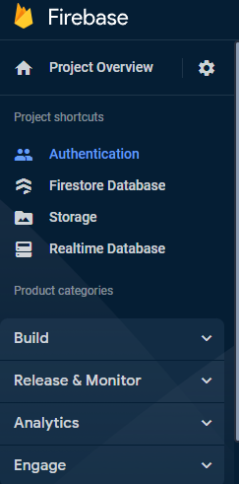

Figure 4.3: Firebase Project Overview

### 4.1.3 XML Layouts

The user interface layouts for our app are made using XML (Extensible Markup Language). To specify the organization and appearance of various screens and UI components, we utilized XML each XML component ID is linked to their respect java ID’s.

### 4.1.4 Glide (Image Loading Library)

Glide is a third-party library that helps to quickly load and show images in our app. This library assists with image loading, image caching, and picture presentation in image views. We implemented this library from GitHub to load user images, app icon and other image features in our game app for a faster and smooth experience.

### 4.1.5 Recycler View

List and grids in our app were displayed using the Recycler View, a strong and adaptable widget. We used it for displaying our user list, course preferences, leaderboards and other dynamic data in our app.

### 4.1.6 Version Control (Git and GitHub)

Utilizing version control, such as Git, is essential for tracking changes and collaborating on the project. Git is a popular version control program. We hosted our whole packages on GitHub as we collaborate working on it.

### 4.1.7 Device for Physical Testing

While emulators are helpful, testing on actual hardware is necessary to make sure your software functions as intended on a variety of hardware. We alongside development test our app using various physical mobile devices.

## 4.2 DATABASE IMPLEMTATION

Google Firebase platform was our choice of database used in implementation for our proposed system. Firebase is a comprehensive platform provided by Google that offers a range of cloud-based services for building and scaling mobile and web applications. While implementing an Android app aimed at improving teaching and learning computer science theoretical courses through gamification, Firebase help play a crucial role in various aspects of our app's development. Here's how Firebase was used:

### 4.2.1 Authentication (Firebase Authentication)

Firebase Authentication allows us to manage user authentication and authorization for our stakeholders. We implemented secure user registration and login functionalities, ensuring that only authorized users can access the app's features as well as users’ data privacy.

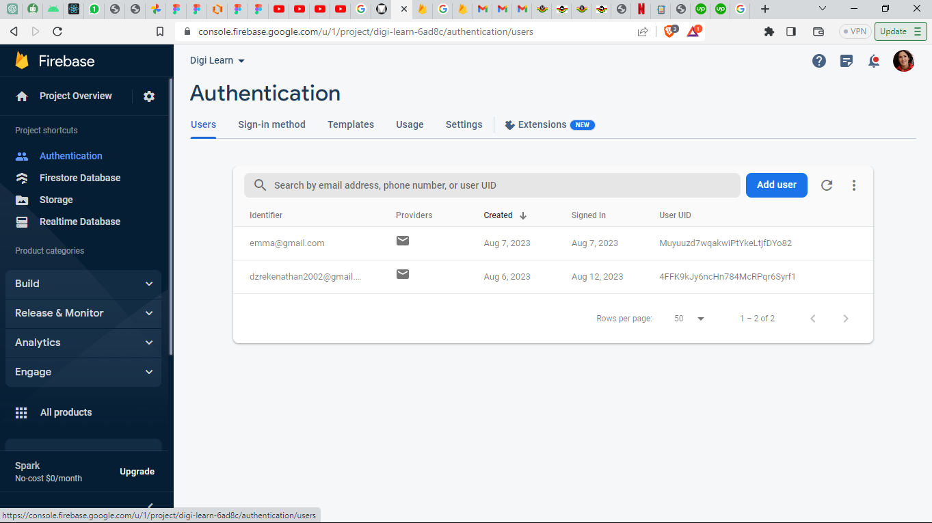

Figure 4.4: Firebase Authentication

### 4.2.2 Real-Time Database

Firebase Real-time Database is a NoSQL cloud database that enables us to store and synchronize data in real-time. We used Firebase to store user profiles, course information, gamification-related data, user progress, and achievements. For example, we created collections for users, courses, quizzes, posts, and achievements. Each user's data is structured as documents within the "users" collection, making it easy to retrieve and update user-specific information.

### 4.2.3 Storage (Firebase Cloud Storage)

Our app involves uploading of user images and avatar where other users can recognize their colleagues using the app with them while they compete among each other and view others stories. This images with the help of Firebase Cloud Storage are stored and retrieved through a generated link on the system. Firebase Cloud Storage was used to store these files securely.

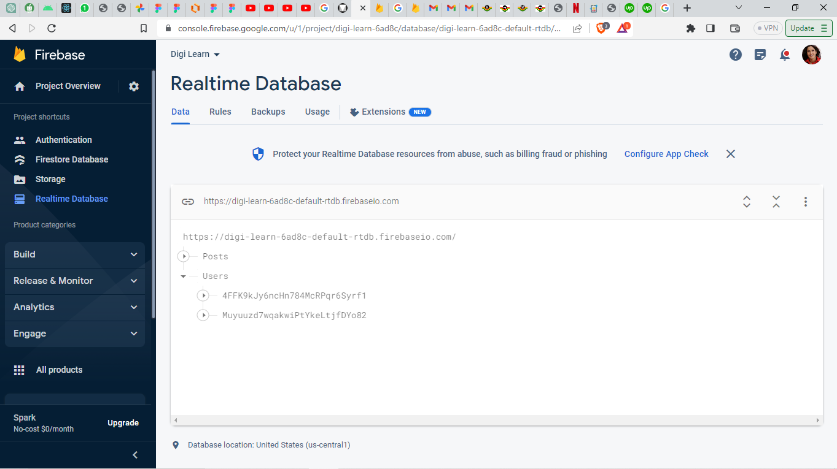

Figure 4.1: Firebase Realtime Database

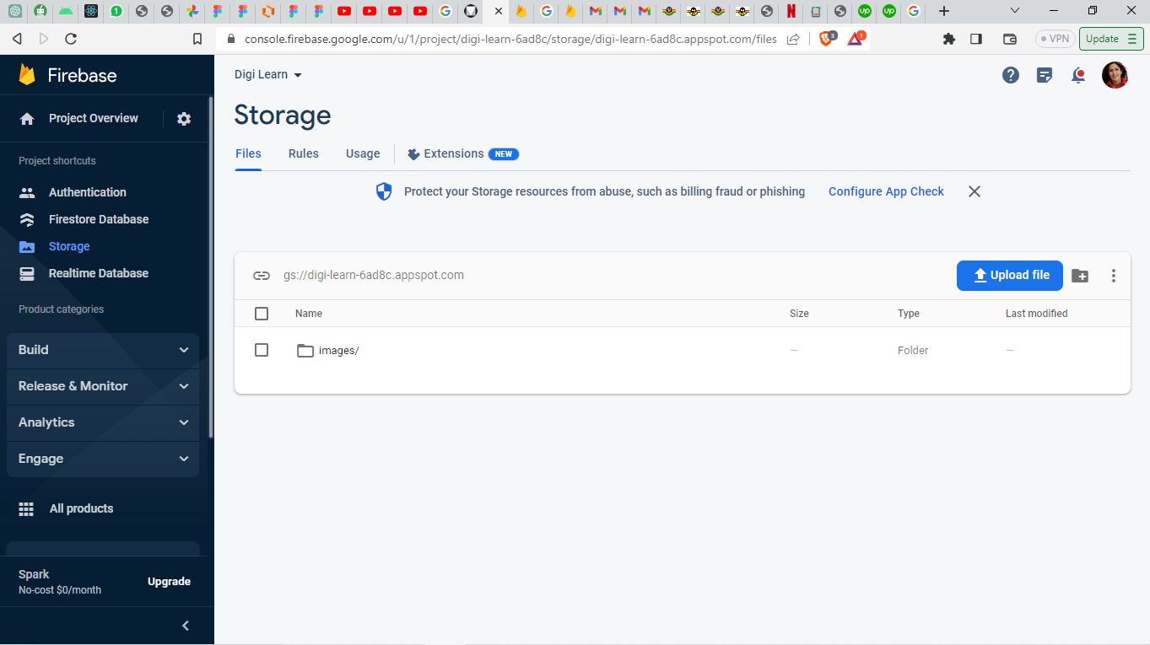

Figure 4.5: Firebase Cloud Storage

### 4.2.4 Cloud Functions (Firebase Cloud Functions)

Firebase Cloud Functions allows us to run server-side code in response to events triggered by Firebase features and HTTPS requests. We used Cloud Functions to perform background tasks, such as calculating and updating user scores, sending notifications, and managing data consistency. For example, when a user completes a quiz, we used a Cloud Function to update their points and achievements in the database, ensuring that data remains consistent across all devices.

### 4.2.5 Push Notifications (Firebase Cloud Messaging)

Firebase Cloud Messaging (FCM) enables us to send push notifications to users' devices. We used FCM to send notifications to remind students of upcoming challenges, new gamified activities, or their achievements. Push notifications helps keep users engaged and informed about the latest activities and progress in the app.

By leveraging the various features provided by Firebase, we implemented a robust and feature-rich Android app for improving teaching and learning Computer Science theoretical courses through gamification. Firebase's integrated services enabled us to handle user authentication, data storage, real-time updates, notifications, analytics, and more, thereby streamlining the development process and enhancing the user experience.

## 4.3 SYSTEM REQUIREMENTS

The system requirement, commonly referred to as the functional specification, specifies what the system must be able to perform. System requirements are more detailed descriptions of the features, services, and operating restrictions of a software system. The specifications in this project correspond to what the students wanted from the suggested mobile app game system. Functional and non-functional requirements were used to categorize the services that the system must provide in this study.

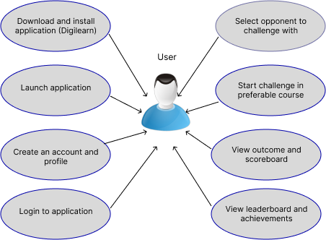

Figure 4.6: Use Case Diagram

### 4.3.1 User Requirements

User requirements are plain language statements accompanied by diagrams that specify what services the system is expected to offer to system users as well as the limitations under which it must function. Figure 4.5 shows our use case diagram. The following defines our proposed system’s user requirements: The proposed computerized gamification mobile app system will enable users create an account, challenge each other, share ideas through text and image posts, show a list of top players on leaderboards and show users achievements.

### 4.3.2 Functional Requirements

Functional requirements outline the task that the system must do as well as the procedures needed, the kinds of data that will be used, and the user interfaces. The following are some of the functional criteria for our proposed system:

* **User Authentication:**
  + Students should be able to create accounts and log in using their credentials.
  + Students should have the option to reset their passwords if forgotten.
* **Course Selection and Enrollment:**
  + Students should be able to view a list of available computer science theoretical courses.
  + Students should have the ability to enroll in specific courses of their choice.
* **Gamification Features:**
  + Students should earn points for completing gamified activities, quizzes, and challenges.
  + Students should be able to view their points, progress, and achievements.
* **Interactive Learning Activities:**
  + Students should be able to access interactive activities and mini-games that reinforce theoretical concepts.
* **Leaderboards and Competition:**
  + Students should be able to view leaderboards that display their rankings based on points.
  + Students should have the ability to compete with peers and track their progress.
* **Notifications and Reminders:**
  + Students should receive push notifications for upcoming challenges, quizzes, and new activities.
* **User Profiles:**
  + Students should have profiles where they can view their personal information, achievements, and progress.
  + Students should have the ability to update their profiles, including profile pictures.
* **Achievements and Rewards:**
  + Students should earn badges or rewards for completing challenges and achieving milestones.
  + Students should be able to track their earned achievements.
* **User Feedback and Ratings:**
  + Students should have the ability to provide feedback on gamified activities and overall app experience.
  + Students should be able to rate the effectiveness and engagement level of different gamification elements.
* **App Usability and Intuitiveness:**
  + Students should find the app's navigation and user interface intuitive and easy to use.
  + Students should be able to easily understand how to participate in gamified activities.
* **Feedback Incorporation:**
  + The app should regularly incorporate user feedback to enhance its features and functionalities.

### 4.3.3 Non – Functional Requirements

The nonfunctional requirements identified are the following:

* Security: information about the system should be secure and safe.
* Maintenance: the system permits to be upgraded and modernized when it is necessary.
* Usability: the system can be accessed by the admin and the user without issues or difficulties.
* Performance: this system responds fast to users without any delay or complications.
* User Friendly: the complete system is developed in a standardized way which makes it user-friendly in terms of the interface and easiness concerning understanding its usage.

### 4.3.4 Requirement for System Implementation and Operations

The purpose is to help ATU Computer Science students’ effective installation. The elements required to successfully deploy, operate, and maintain the application targeted at enhancing teaching and learning computer science theoretical courses through gamification are included in the requirements for system deployment and operations of the gamification system. These specifications guarantee a seamless transition from development to practical application and long-term operation. These specifications include the following.

Minimum requirement includes the following:

* Android Version: Android 7.0 (Nougat) or later.
* Screen Size: Recommended minimum screen size of 4.5 inches for optimal readability.
* RAM: At least 2GB of RAM for smooth performance.
* Storage: A minimum of 50MB of available storage space for the app installation.
* Internet Connection: An active internet connection (Wi-Fi or mobile data) for accessing content and receiving notifications.

## 4.4 SYSTEM OVERVIEW

Our System is named “Digi Learn” and consists of an easy to navigate pages which allows Computer Science Students engage in interactive learning activities among each other. All questions and answers are stored in the firebase real-time database. After a successful challenge between two students the results are saved in the database and then later displayed to the players. Students’ leaderboard is constantly updated in real-time to make students determine the most diligent student. All students profile data are also saved in the database and can be updated by the students.

### 4.4.1 User Requirement and Analysis

The user of the system

* Create Account
* Login
* Create profile
* Update profile
* Create a community post – create text or image post where other users share their reactions through likes and comments.
* View Leaderboard – view a display of all players and their score in an ascending order.
* Challenge colleagues – select and challenge any opponent of your choice and in any course.
* Obtain rewards based on achievements – successful tasks such as a win rewards the player.
* Logout – exits from the system

## 4.5 THE PROPOSED SYSTEM’S USER INTERFACES AND EXPERIENCES

This section details the User Interface (UI) and User Experience (UX) of our system from the start screen also known as the splash screen through all screens till the user exits out of the system.

### 4.5.1 Splash Screen

Figure 4.6 is the initial screen that users view when the program is launched. The Splash Screen is the welcoming introduction to our gamification-enhanced learning app. It's the first impression users receive as they open the app, setting the tone for their interactive educational journey. The screen features our app's logo, captivating visuals, and a brief tagline that encapsulates our commitment to making learning engaging and effective. As the screen transitions seamlessly, users feel the anticipation of entering a world of knowledge and excitement.



Figure 4.7: Splash Screen

### 4.5.2 Create Account Form

After the splash screen in Figure 4.6 loads up, the "Create Account" page empowers users to join our community and embark on their educational adventure. Here, users can enter their personal details, including a unique username, first name, last name, student ID, level, a secure password, and an email address. We've designed this page with simplicity and security in mind, guiding users through the account creation process seamlessly. As users submit their information, they become part of our interactive ecosystem, unlocking access to tailored course materials, engaging activities, and the rewards of gamification. By offering a straightforward and intuitive account creation experience, we're dedicated to making education accessible to all. If a user is already authenticated, it moves directly to the home page illustrated in Figure 4.7 else if it is the users’ first time, it moves to the create account screen as show in Figure 4.7 the tap on the create account button sends user to the create profile page where user add some bio data to help other users discover them.

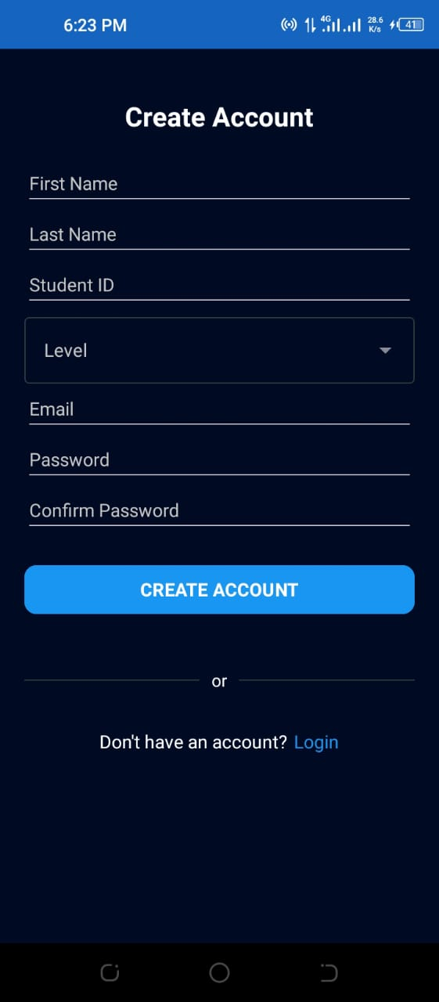

Figure 4.8: Create Account

### 4.5.3 Login Page

The "Login" page in Figure 4.8 is the gateway for our users to continue their educational journey. With their registered credentials, users can effortlessly log in to their accounts, ensuring a personalized experience every time they access the app. Our user-friendly design guarantees easy navigation, with fields for entering usernames and passwords. As users log in, they're welcomed back to their individual profiles, where they can track their progress, engage in gamified challenges, and explore enriching course content. The Login page reflects our commitment to seamless and secure access, creating a bridge between users' digital identity and the transformative learning experiences that await them.



Figure 4.9: Login Page

### 4.5.4 Create Profile

The "Create Profile" page displayed in Figure 4.9 empowers users to establish their digital identity within our educational community. Users can add essential details, user image or avatar, first name, last name, username, email, student ID, telephone contact, social media links, and perhaps a short bio, fostering a sense of belonging. This personalized touch helps users connect their learning journey with their individuality, setting the stage for a unique and engaging experience.

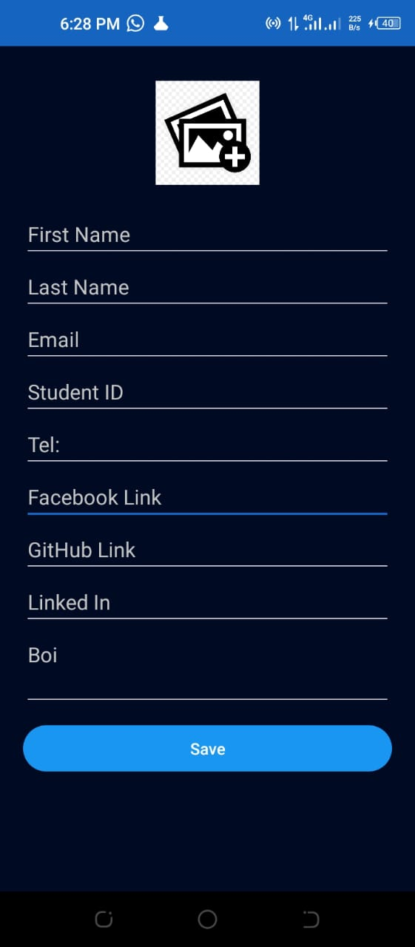

Figure 4.10: Create Profile

### 4.5.5 Profile Page

This section displays all the data a user entered while creating an account. The "User Profile" page is a window into each user's progress and achievements. In Figure 4.10, users can see their accumulated points, earned badges, and bio. It serves as a visual representation of their growth, fostering a sense of accomplishment and motivation to continue engaging with the gamified learning activities.

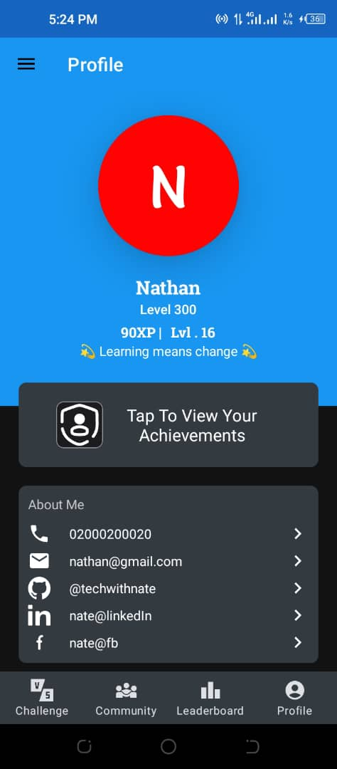

Figure 4.11: Profile

### 4.5.6 Leaderboard

The "Leaderboard" is a dynamic space where users can view their ranks based on points earned. The illustration page in Figure 4.11 encourages healthy competition, motivating users to strive for higher positions and fostering a sense of community interaction. By showcasing top performers, we inspire all users to actively participate and excel in their learning endeavors.



Figure 4.12: Leaderboard

### 4.5.7 Achievements

The "Achievement" page celebrates users' milestones and accomplishments. Users can unlock badges, trophies, and special acknowledgments for reaching specific goals. This feature shown in Figure 4.12 provides a tangible representation of progress and proficiency, enhancing users' satisfaction and spurring their enthusiasm for further engagement.

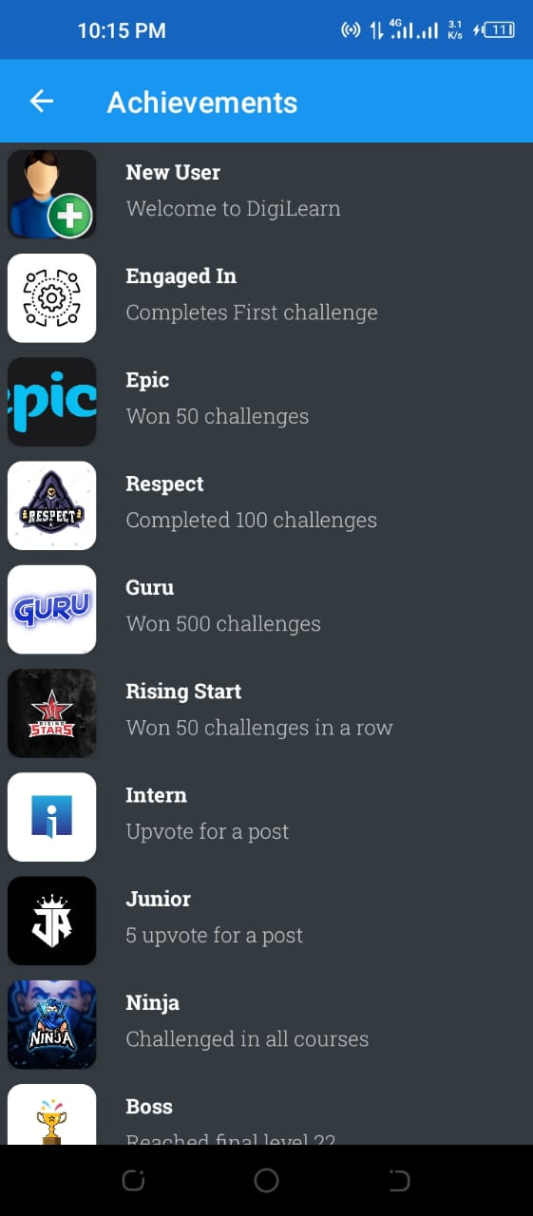

Figure 4.13: Achievement Page

### 4.5.8 Challenge

The "Challenge" feature immerses users in a dynamic and educational experience. Users can challenge friends or fellow learners to gamified activities or quiz games and also choose from various quizzes related to computer science theoretical courses as shown in Figure 4.13 with a time limit, each question challenges users to think quickly and critically, applying their knowledge in a fun and competitive environment.



Figure 4.14: Challenge Page

### 4.5.9 Results

The "Results" page in Figure 4.14 displays users' performance after completing a quiz game or challenge. It provides instant feedback on correct and incorrect answers, along with their final score. This feature encourages self-assessment and helps users identify areas for improvement.



Figure 4.14: Result Page

### 4.5.10 Community

The "Community" section is a collaborative hub where users can interact, ask questions, and share insights. As represented in Figure 4.15 it includes discussion boards, forums, or chat features that foster a sense of belonging and encourage the exchange of ideas among learners. This sense of community enhances the overall learning experience by providing a platform for knowledge sharing and peer support.



Figure 4.15: Community Page

# CHAPTER FIVE

# SUMMARY, CONCULSIONS AND RECOMMENDATIONS

## 5.0 CONCLUDING REMARKS

In this research project, we created a computerized mobile game to improve teaching and learning of computer science theoretical courses in the Computer Science Department of ATU. We used a quantitative method (questionnaire via online Google Forms) to obtain data from students in the Computer Science Department. 318 complete responses were received for effective data analysis. Furthermore, we also adopted a qualitative method (Interview) to obtain responses from lecturers teaching computer science theoretical courses. Results in this research shows that a majority of the participants in the research are eager to accept Gamification as a tool for improving teaching and learning Computer Science theoretical courses. As shown in this project report, our proposed mobile-based gamification software solution provides an entertaining and encouraging platform for Computer Science students in ATU. This represents a step forward in improving teaching and learning of CPS theoretical courses.

## 5.1 RECOMMENDATIONS

Based on the research study, the following recommendations were made for students and instructors in Accra Technical University Computer Science Department:

* We recommend that, for proper and effective implementation of our developed system, lecturers teaching theoretical courses in the Computer Science department should have access to the database where they can frequently add more challenging questions and puzzles for students to solve.
* We recommend that the user data should be properly examined and monitored by some delegated individuals to determine the number of students using the app, their engagement as well as it’s improvement in their performance.
* We recommend that the system to be maintained and upgraded to improve and encourage students in using it.

**REFERENCES**

Bamford, J. (2002). *Body of secrets: Anatomy of the ultra-secret National Security Agency*. Anchor.

Davis, C. R. (1956). The Personnel Security Program. *JAG J.*, 3.

Soomro, Z. A., Shah, M. H., & Ahmed, J. (2016). Information security management needs more holistic approach: A literature review. *International journal of information management*, *36*(2), 215-225.

Safa, N. S., Von Solms, R., & Furnell, S. (2016). Information security policy compliance model in organizations. *computers & security*, *56*, 70-82.

Adipat, S., Laksana, K., Busayanon, K., Ausawasowan, A., & Adipat, B. (2021). Engaging Students in the Learning Process with Game-Based Learning: The Fundamental Concepts. *International Journal of Technology in Education*, *4*(3), 542–552. https://doi.org/10.46328/ijte.169

An, Y. (2020). Designing Effective Gamified Learning Experiences. *International Journal of Technology in Education*, *3*(2), 62. https://doi.org/10.46328/ijte.v3i2.27

Bourke, B. (2020). Using gamification to engage higher-order thinking skills. *Research Anthology on Developing Critical Thinking Skills in Students*, *January*, 632–652. https://doi.org/10.4018/978-1-7998-3022-1.ch033

Deterding, S., Dixon, D., Khaled, R., & Nacke, L. (2011). From game design elements to gamefulness: Defining “gamification.” *Proceedings of the 15th International Academic MindTrek Conference: Envisioning Future Media Environments, MindTrek 2011*, 9–15. https://doi.org/10.1145/2181037.2181040

Dichev, C., & Dicheva, D. (2017). Gamifying education: what is known, what is believed and what remains uncertain: a critical review. In *International Journal of Educational Technology in Higher Education* (Vol. 14, Issue 1). International Journal of Educational Technology in Higher Education. https://doi.org/10.1186/s41239-017-0042-5

Gil-Acirón, L. Á. (2022). Benefits of Gamification in Second Language Learning. *Epos : Revista de Filología*, *38*, 103–126. https://doi.org/10.5944/epos.38.2022.33785

Jerry P. Gollub, Meryl W. Bertenthal, Jay B. Labov, and Philip C. Curtis, E. (2002). Learning and Understanding. In *Learning and Understanding*. https://doi.org/10.17226/10129

Johnson, C., Mcgill, M., Bouchard, D., Bradshaw, M. K., Bucheli, V. A., Merkle, L. D., Scott, M. J., Sweedyk, Z., Ángel, J., Xiao, Z., & Zhang, M. (2016). Game development for computer science education. *Proceedings of the 2016 ITiCSE Working Group Reports, ITiCSE 2016*, *February 2018*, 23–44. https://doi.org/10.1145/3024906.3024908

Koivisto, J., & Hamari, J. (2019). The rise of motivational information systems: A review of gamification research. *International Journal of Information Management*, *45*(December 2018), 191–210. https://doi.org/10.1016/j.ijinfomgt.2018.10.013

Landers, R. N. (2015). *Developing a Theory of Gamified Learning : Linking Serious Games and Gamification of Learning*. *January*. https://doi.org/10.1177/1046878114563660

Lee, J. J. C. U., & Hammer, J. C. U. (2011). Gamification in Education: What, How, Why Bother? *Academic Exchange Quarterly*, *15*(2), 1–5. http://www.mendeley.com/research/gamification-education-bother-2/

Li, C., Dong, Z., Untch, R. H., & Chasteen, M. (2013). Engaging Computer Science Students through Gamification in an Online Social Network Based Collaborative Learning Environment. *International Journal of Information and Education Technology*, *3*(1), 72–77. https://doi.org/10.7763/ijiet.2013.v3.237

Mee Mee, R. W., Shahdan, T. S. T., Ismail, M. R., Abd Ghani, K., Pek, L. S., Von, W. Y., Woo, A., & Rao, Y. S. (2020). Role of gamification in classroom teaching: Pre-service teachers’ view. *International Journal of Evaluation and Research in Education*, *9*(3), 684–690. https://doi.org/10.11591/ijere.v9i3.20622

Mposula, N. F. (2019). *Gamification as a tool for developing critical thinking among ICT students at a tertiary institution in South Africa*. *September*. http://ir.cput.ac.za/handle/20.500.11838/3020

Nair, S., & Mathew, J. (2019). A theoretical framework for gamified learning. *International Journal of Innovative Technology and Exploring Engineering*, *8*(12), 2846–2851. https://doi.org/10.35940/ijitee.L3032.1081219

Özdamli, F., & Yazdeen, D. F. (2021). Gamification in Computer Science Courses: a Literature Review. *Near East University Online Journal of Education*, *4*(2), 90–106. https://doi.org/10.32955/neuje.v4i2.345

Poondej, C., & Lerdpornkulrat, T. (2016). The development of gamified learning activities to increase student engagement in learning. *Australian Educational Computing*, *31*(2).

Rabah, J., Cassidy, R., & Beauchemin, R. (2018). Gamification in education: Real benefits or edutainment? *Proceedings of the European Conference on E-Learning, ECEL*, *2018*-*Novem*(June), 489–496. https://doi.org/10.13140/RG.2.2.28673.56162

Smiderle, R., Rigo, S. J., Marques, L. B., Arthur, J., Miranda, P. De, & Jaques, P. A. (2020). *The impact of gamification on students ’ learning , engagement and behavior based on their personality traits*.

Zahedi, L., Ross, M. S., & Batten, J. S. (2019). Implications of gamification in learning environments on computer science students: A comprehensive study. *ASEE Annual Conference and Exposition, Conference Proceedings*, *June*. https://doi.org/10.18260/1-2--32946

ZAMANIAN, Z., DEHGHANI, M., MOHAMMADY, H., REZAEIANI, M., & DANESHMANDI, H. (2012). Investigation of Shift Work Disorders among Security Personnel. *International Journal of Occupational Hygiene*, *4*(2), 39–42.

Zaric, N., Roepke, R., Lukarov, V., & Schroeder, U. (2021). Gamified learning theory: The moderating role of learners’ learning tendencies. *International Journal of Serious Games*, *8*(3), 71–91. https://doi.org/10.17083/IJSG.V8I3.438

Zhan, Z., He, L., Tong, Y., Liang, X., Guo, S., & Lan, X. (2022). The effectiveness of gamification in programming education: Evidence from a meta-analysis. *Computers and Education: Artificial Intelligence*, *3*(June), 100096. https://doi.org/10.1016/j.caeai.2022.100096

**appendix**

**SURVEY QUESTIONNAIRE FOR STUDENTS**

## 6.0 INTRODUCTION

We are HND final year students from the Department of Computer Science, Accra Technical University (ATU), undertaking research on the topic **“Improving Teaching and Learning of Computer Science Theoretical Courses Through Gamification”**. Focusing on the current challenge of effective and innovative pedagogy in teaching and learning, our research project initially aims to investigate and analyze some selected Computer Science theoretical courses in ATU. Then, we will propose a computerized software solution which involves a mobile-based game for ATU students. Our proposed computerized solution seeks to solve the above problem by enabling students to improve their engagement with learning Computer Science theoretical courses. Furthermore, our study aims to improve the traditional method of teaching and learning of Computer Science theoretical courses in Accra Technical University.

Kindly spare us a few minutes of your time by filling in the questionnaire to help us achieve our research objectives and answer our research questions accurately. Due to ethical reasons, the questions do not involve any responses regarding your personal information and your responses will be kept completely confidential and used for academic purposes only. Please provide your feedback to the questions below appropriately, thank you.

Our proposed **Gamification** is a mobile-based gaming application for ATU Computer Science students where gaming techniques are integrated to improve the traditional method of teaching and learning Computer Science theoretical courses. This provides an alternative way to the traditional way of teaching and learning. Our Game platform will be deployed on a mobile device for students to access.

**INSTRUCTIONS**

**Please answer the questions below by ticking appropriately.**

**DEMOGRAPHY**

1. What is your age?
   * 15 - 20 Years
   * 21 - 30 Years
   * 31 – 40 Years
   * 41 Years Above
2. What is your gender?

* Male
* Female

1. What is your level in Computer Science?

* Level 100   
  Level 200
* Level 300

1. Are you a full-time or part-time student?

* Full-time
* Part-time

1. What teaching methods are currently used in Computer Science theoretical courses at Accra Technical University?

* Traditional teaching methods
* Advance and Technological Teaching Methods

1. What challenges do you face as a student in understanding Computer Science theoretical concepts?

* Easy understanding of concepts
* Difficult understanding concepts

|  |  |  |  |  |  |
| --- | --- | --- | --- | --- | --- |
|  | **1**  **Strongly Disagree** | **2**  **Disagree** | **3**  **Neither Agree or Disagree** | **4**  **Agree** | **5**  **Strongly Agree** |
| 1. The current mode of teaching and learning Computer Science theoretical courses is easy to understand. |  |  |  |  |  |
| 1. The current way of teaching provides me with industry standards and practices. |  |  |  |  |  |
| 1. I find myself motivated and engaged during classes for CPS theoretical courses. |  |  |  |  |  |
| 1. There are collaborative activities incorporated into teaching and learning in the Computer Science Department. |  |  |  |  |  |
| 1. Aside instructional hours, I have been able to interact with lecturers. |  |  |  |  |  |

**Please use the Five-Point Likert Scale to Answer the Questions Below**

1. How would you rate the interaction and engagement between students and lectures during CPS theoretical courses period?

Not Effective 1[ ] 2[ ] 3[ ] 4[ ] 5[ ] Very Effective

1. How would you rate the feedback and guidance provided by instructors in Computer Science theoretical courses?

Not Effective 1[ ] 2[ ] 3[ ] 4[ ] 5[ ] Very Effective

1. How would you rate the assessment methods used to evaluate your understanding of Computer Science theoretical concepts?

Not Effective 1[ ] 2[ ] 3[ ] 4[ ] 5[ ] Very Effective

1. What device do you use mostly?

* Laptop
* Smartphone

**Please use the Five-Point Likert Scale to Answer the Questions Below**

|  |  |  |  |  |  |
| --- | --- | --- | --- | --- | --- |
|  | **1**  **Strongly Disagree** | **2**  **Disagree** | **3**  **Neither Agree or Disagree** | **4**  **Agree** | **5**  **Strongly Agree** |
| 1. I would accept games as a method of teaching and learning Computer Science theoretical courses. |  |  |  |  |  |
| 1. I would find gamification useful as a tool of learning Computer Science theoretical courses. |  |  |  |  |  |
| 1. Using game tools would enable me to enhance my knowledge in Computer Science theoretical courses. |  |  |  |  |  |
| 1. It is easy for me to access games anytime anywhere. |  |  |  |  |  |
| 1. Gamification will increase my motivation in learning Computer Science theoretical courses. |  |  |  |  |  |
| 1. My interaction with game tools will enable me develop more interest in learning Computer Science theoretical courses. |  |  |  |  |  |
| 1. Gamification will be a better improvement of the method of teaching and learning Computer Science theoretical courses. |  |  |  |  |  |
| 1. Games will be easy to use when learning. |  |  |  |  |  |
| 1. I use other related game sites and services to learn Computer Science theoretical courses. |  |  |  |  |  |
| 1. I would recommend gamification to others offering Computer Science. |  |  |  |  |  |
| 1. I have the necessary devices to play games. |  |  |  |  |  |
| 1. I prefer gamification to the current method of teaching Computer Science theoretical courses. |  |  |  |  |  |

**Thank you for your participation.**